Edenmore National School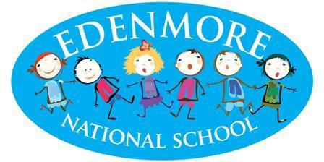
Healthy Eating Policy

- Introduction
This policy has been drafted by the Edenmore Wellbeing committee in consultation with the Principal, whole staff and Parents Association. This Healthy Eating Policy forms part of our Social, Personal and Health Education and Physical Education policies within Edenmore N.S.
Our Healthy Eating Policy outlines how the school supports healthy eating practices through the promotion of healthy lunches and healthy snacks and by other means. The SPHE Guidelines aim to promote the personal development and wellbeing of the student to provide a foundation for healthy living in all its aspects.

- Policy Rationale
Edenmore National School is committed to facilitating the children’s development of skills and attitudes to allow them to make informed decisions about their food intake. We aim to promote the development of the whole child, physically, mentally, spiritually and emotionally. Our school recognises that a healthy diet is essential for maintaining and protecting children’s health, for ensuring they perform to their full potential during the school day (both academically and physically) and for their growth and development. There will be a whole school approach, involving teachers, parents and children to ensure that healthy eating messages are a part of every aspect of school life. The children will continue to receive consistent messages regarding healthy eating both at home and at school.

- Benefits of a good diet

- Ensures the development of healthy hair, skin, teeth, muscles and strong bones
- Provides energy and aids concentrate
- Strengthens the immune system

- Aims of our Healthy Eating Policy

- To promote a whole school approach to healthy eating and nutrition
- To understand the benefit of a healthy well balanced diet
- To develop an awareness that good eating habits formed in early childhood influence health and wellbeing throughout our lives
- To develop awareness of the importance of food for growth and development
- To explore food preferences in a balanced diet.
- Raise levels of concentration within class through the consumption of healthy food
- Provide members of staff, parents and those involved in school activities with clear information
- Protect the health and safety of children with serious food allergies.
- To promote personal well-being and confidence through diet, activity and dental hygiene.

- Implementation

Break/Lunch Time
The children have an exercise break from 10.50am to 11am and 12:30pm - 1:00pm. A snack is eaten in class before going outside for small break so food at this break should be easy to eat, ideally a small sandwich or a piece of fruit. Fruit should be of a manageable size, peeled/chopped if necessary and we require that grapes are cut to avoid a risk of choking.
Hot school meals are delivered to the classes at 12:15pm to allow sufficient time to eat prior to outdoor play time.

- Food items not permitted in school (this list is not exhaustive):
- Nuts (including peanut butter and nutella) *
- Fizzy drinks, sports drinks and drinks/juices due to high sugar content
- Chocolate including chocolate spread and chocolate covered bars, rice cakes
- Sweets & winders due to their high sugar content
- Biscuits/cakes/muffins/traybakes (including homemade)
- Dessert type yoghurts ( such as ‘Crunch Corners’ )
- Cereal Bars except plain ‘Nutrigrain’ bars.
- Crisps & popcorn* (due to choking hazard)
- Lollipops *
- Chewing gum*

*These foods are not permitted at ANY time in school, even on treat days.

- Special Treats
Sweets and treats are not given as rewards by staff members.
On some special occasions and end of term days during the school year the children will be permitted special treats. Children may bring in treats to share with others on these occasions, but only if enough to include their class group.

- Best Practice

- Ensure your child starts the day with a good breakfast
- Eat small regular meals, not one big meal each day
- Children who take physical exercise each day will have a better appetite for healthy food
- Serve brown bread instead of white
- Cut large rolls/wraps/sandwiches into more manageable sizes
- The children will bring home uneaten lunch.
- Allergies
In order to protect children who have serious food allergies, the whole school community will work together to implement age appropriate, responsible measures to minimise the risk of an allergic reaction. All children in the school will be made aware of the implications of food allergies and how they can assist in preventing allergic reactions.
If your child has a serious food allergy, as parents/guardians you must notify the school and provide a doctor’s report stating the implications of the allergy and listing the foods to be avoided. You will be asked to participate with staff in formulating an individual allergy management plan. This plan will identify how best to minimise the risk of an allergic reaction for your child, taking her/his age and class into account. The individual allergy management plan may result in precautions or class specific restrictions, in addition to those of not sharing food or containers, being put in place. They are called class specific restrictions, as they will only apply to the class in which there is a child with a life-threatening allergy. Where class specific restrictions are required, the parents/guardians of all children in the affected class will be informed by a letter explaining what the restrictions are and the reasons for them. These will be regularly reviewed and updated, and any changes will be communicated in writing.
We currently implement a whole school ban on nuts due to the amount of children presenting with nut allergies in our school across a number of classes.

- Hot School Meals
The Dept. of Education granted funding to Edenmore N.S. for free hot school meals in April 2024. The Hot School Meals aims to provide nutritious food daily for all students in the school. As outlined in the “Nutrition Standards for Hot School Meals” guidelines published by Healthy Ireland every hot school meal should contain: 2 servings of vegetables, salad or fruit/ 1 serving of wholemeal cereals and breads, potatoes, pasta and rice/ 1 serving of meat, poultry, fish, egg, beans and nuts. Daily hot lunches are provided by a local external catering company and delivered to the school daily.
- Roles and Responsibilities of Parents in Supporting this Policy

- Parents are responsible for providing a healthy school snack for their child(ren) as per the guidelines of this policy.
- Parents are encouraged to discuss the importance of healthy eating with their children so they can make informed food choices.

- Roles and Responsibilities of Teachers in Supporting this Policy

- Teachers will explicitly teach about healthy eating as part of the SPHE curriculum.
- The school will focus on healthy Eating during Wellbeing Week annually and will also participate in government initiatives as and when they are offered to us.
- A note will be sent home if pupils bring contraband food into school and recurring incidents will result in a meeting with class teacher or school management to discuss
- Our Healthy Eating Policy will be reviewed every three years
- Edenmore National School’s Healthy Eating Policy is available on our school website.

- Children with special dietary needs
In Edenmore we understand the children with Special Educational Needs may present with sensory issues around food and food choices. We would encourage parents to try and explore different foods in accordance with this policy but we will accommodate any sensory/dietary requirements as deemed necessary by external agencies.

- Success Criteria
We will know if the policy is effective by:
- Observing what children have for lunch and during other break times.
- The feedback from parents/guardians and school staff
- The level of concentration and performance of children in the classrooms

- Ratification and Review:
This policy has been made available to school personnel, issued to the Parents’ Association and to all parents via Aladdin and published on the school website. A copy of this policy will be made available to the Department of Education and to the Patron if requested.

This policy and its implementation will be reviewed by the Board of Management every three years. Written notification that the review has been completed will be made available to school personnel, published on the school website and provided to the Parents’ Association. A record of the review and its outcome will be made available to the Department of Education and Skills and to the Patron if requested.

_____________________________________________________________________________
This policy was adopted by the Board of Management on 15th April 2024

Signed: _________________________ Signed: ____________________________
Chairperson of Board of Management Principal

Date: __________________________ Date: ___________________

Appendix 1.
Suggestions for your child’s school lunch
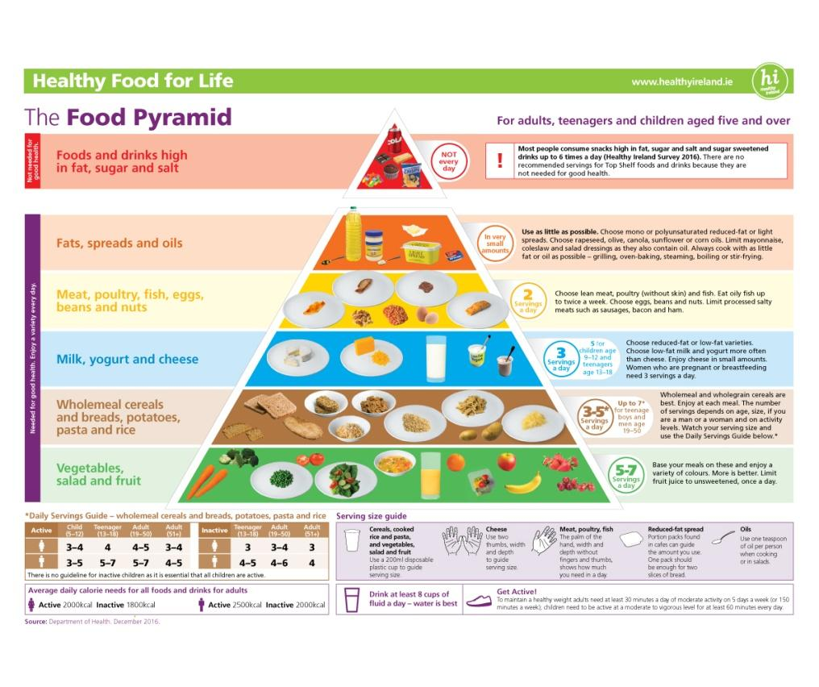
- Breads – whole-grain breads, rolls, bagels, wraps, soda bread or pitta
- Bread substitutes – oatcakes, plain rice cakes, pancakes or crackers
- Fillings – cheese, tuna, hummus, cold meats, pate, egg, lettuce, spinach, cucumber, tomato, onion, peppers, coleslaw, salad, or banana
- Hot leftovers in a flask – curry, pasta (with or without sauce), soup/chowder, baked beans, rice, stew, lasagne or noodles
- Cold leftovers
- Fruit – apple, oranges, banana, grapes, pear, plum, peach, apricots, melon, grapefruit, pineapple, strawberries, raspberries, mango, blackberries or blueberries. Remember to peel and/or cut fruit and vegetables into bite-sized pieces for younger children
- Raw vegetables – tomatoes, sweet corn, peppers, carrot sticks, celery sticks, broccoli, cabbage or cucumber

